Safe Steps Respite
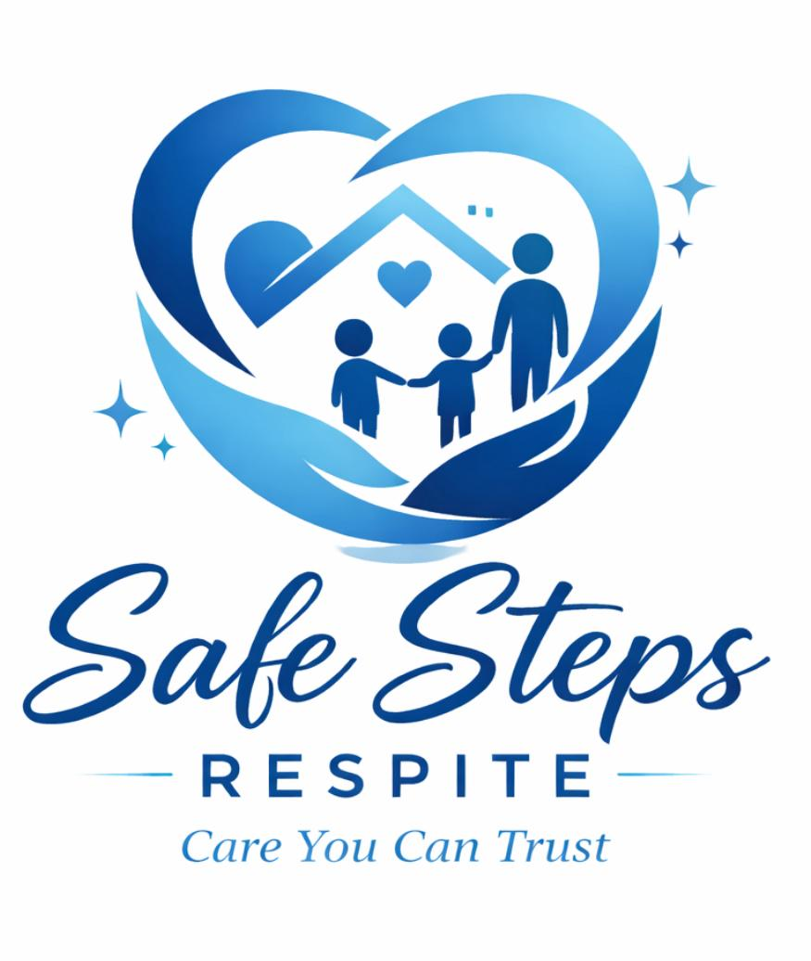

Statement of
Commitment to Child Safety
At Safe Steps Respite every child has the right to be safe and feel safe. We commit to the safety and wellbeing of every child in our care.
To keep children safe, we commit to:
- implementing the 10 Child Safe Standards
- providing a safe and supportive environment for all children
- making sure that children are not exposed to any form of harmful conduct or abuse
- empowering children to participate in decisions that affect them and share any concerns they may have
- making sure children know who to approach if they feel unsafe or have any child safety concerns.
As a child safe organisation, we commit to:
- educating everyone involved in our organisation about what it means to be a child safe organisation, so that we can prevent, detect and effectively respond to child abuse
- making sure everyone involved in our organisation knows how to appropriately respond to complaints, allegations, disclosures and breaches to our Child Safe Code of Conduct
- welcoming feedback to continuously improve our child safe policies, procedures and practices
- making sure that when family and community members interact with our organisation, they are aware that child safety is everyone’s responsibility, and their behaviour aligns with our child safe practices.
Note
link to Safe Steps Respite website for more child safe policies and procedures. www.safestepsrespite.com.au

For more free child safe resources, visit ocg.nsw.gov.au/our-resources.

